MANMOHAN TECHNICAL UNIVERSITY

SCHOOL OF ENGINEERING

DEPARTMENT OF

ELECTRICAL AND ELECTRONICS ENGINEERING



"AUTOMATIC WATER PUMP CONTROLLER"

Submitted by:

Pabitra khaptrai (7)
Rajkishor sardar (10)
Rajshree Malla Thakuri (11)
Sushil dulal (15)

Submitted to:
Department of Electrical and Electronics Engineering

November 19 /2024

MANMOHAN TECHNICAL UNIVERSITY
SCHOOL OF ENGINEERING
DEPARTMENT OF
ELECTRICAL AND ELECTRONICS ENGINEERING

The undersigned certify that they have read and recommended to the Manmohan Technical University School of Engineering for acceptance, a final project report entitled “Title here” submitted by Mr. Name Here in partial fulfillment of the requirements for the degree of Bachelor of Electrical and Electronics Engineering.

…………………………..
(Er sagun paudyal)
(Dr-Ing Deepranjan dongol)
Supervisor
Full designation
Organization

……………………………..
(Dr-Ing Deepranjan dongol)
Head of Department
Full designation
Organization

ACKNOWLEDGEMENT
We would like to express our deepest gratitude to all those who contributed to the successful completion of the Automatic Water Pump Controller project.
Firstly, we are immensely grateful to our project supervisors, Dr.-Ing. Deepranjan Dongol and Er. Sagun Paudyal, for their invaluable guidance, constant encouragement, and insightful suggestions throughout this project. Their expertise and advice were crucial to the successful design and implementation of this system.
We would also like to thank Manmohan Technical University for providing the necessary resources and support that enabled this project to be completed effectively. Special thanks are extended to the technical staff for their assistance with hardware setup and troubleshooting.
We sincerely appreciate the contributions and efforts of everyone involved in making this project a success.
.
ABSTRACT

This project focuses on the development and implementation of an automatic water pump controller system designed to manage water levels in underground and overhead tanks efficiently. The primary objective is to automate the water pumping process to maintain optimal water levels without manual intervention. The system utilizes a combination of electronic components, including a 555 timer IC, transistors (BC547), and a 12V relay to control the activation and deactivation of a water pump based on sensor feedback from both the underground and overhead tanks.
The circuit detects water levels using conductive sensors placed at strategic points in the tanks. When the water level in the overhead tank drops below a set threshold, the controller automatically switches on the pump, drawing water from the underground tank. Once the overhead tank reaches its maximum capacity, the pump is switched off to prevent overflow. Additionally, the system incorporates safety features such as a manual stop switch for emergency shutdown and an LED indicator for status monitoring.
The results demonstrate that the automatic controller efficiently manages water levels, ensuring a consistent water supply while minimizing energy consumption and water wastage. This automated approach provides a reliable solution for household water management, significantly reducing the need for manual supervision. The successful implementation of this system highlights its potential application in residential and commercial water supply systems, promoting water conservation and efficient resource management.

TABLE OF CONTENTS

TITLE Page no

Certificate of Approval……………………………………………………... ii
Acknowledgement …………………………………………………………...iii Abstract ………………………………………………………………………iv Chapter 1: Introduction …………………………………………………….2 1.1 Background ……………………………………………………………... 2 1.2 Problem statement ……………………………………………………….3
1.3 Objective of the project…………………………………………………..4
1.4 Literature study…………………………………………………………..5
Chapter 2:System Description………………………………………………6
2.2 System Architecture and Components………………………………….6
2.3 Component Required…………………………………………………….7
2.4 Circuit Diagram and Working Principle………………………………..9
Conclusion and Recommendation For Improvements…………………….10
References……………………………………………………………….……..11

CHAPTER 1 : INTRODUCTION

An introduction to the automatic water pump controller system is given in this section. The motivation behind developing this system stems from the challenges faced in managing water supply in Nepalese industries and households. Manual operation of water pumps often results in water wastage, dry running of pumps, and increased energy consumption, highlighting the need for an automated and efficient solution. To address these issues, an extensive study was conducted to analyze existing systems and identify the best methods and components for automated water management. This research contributed to the design of a more effective system tailored to local needs. The new system aims to provide a reliable and energy-efficient way to monitor water levels and control pumps, making it a key feature of this project.

  - Background
An automatic water pump controller system is designed to automate water management for efficient use in residential or industrial settings. The system detects water levels in both an underground and an overhead tank, using sensors to monitor these levels in real time. When the water in the overhead tank drops below a set threshold, the controller automatically starts the pump to refill the tank from the underground reservoir. Once the overhead tank reaches its maximum level, the pump is switched off to prevent overflow. This setup eliminates the need for manual intervention and reduces water wastage, improving both convenience and resource efficiency. The accompanying circuit diagram shows the configuration, where sensors detect water levels, and a relay circuit controls the motor, automating the entire pumping process.
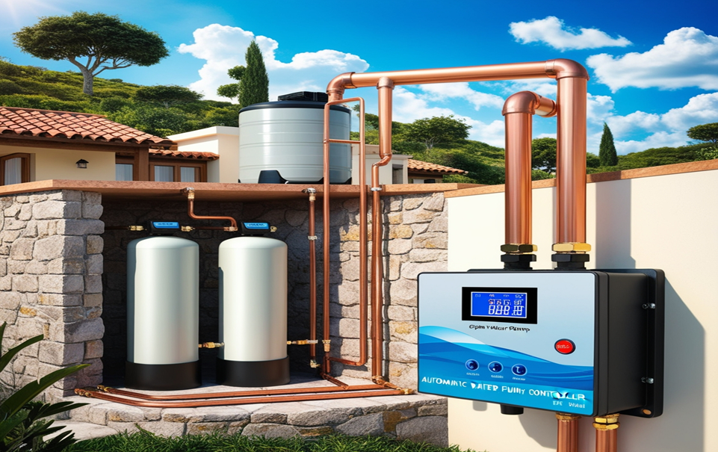
  - Problem statement
In Nepal, a significant issue with current automatic water pump controllers, particularly in residential and agricultural settings, is that they tend to be unnecessarily complex and costly. Most of these systems incorporate advanced arrangements of sensors, programmable logic controllers, or even computer interfaces. Typically imported and designed for large-scale applications, these systems often exceed the local needs and practical uses.
For example, some water pump controllers integrate microcontrollers with sensor networks and computer systems, aiming to provide extensive control and monitoring capabilities. This level of sophistication may be suitable for high-end setups, but it is generally excessive for Nepal’s basic water pump needs. Systems like these are often created to manage multiple water sources or to be integrated with industrial control systems, adding unneeded layers of complexity for users who simply need efficient, affordable water pump control.
The primary drawback of this complex setup is its high cost and the inflexibility it introduces. Since these controllers are programmed for a specific environment, relocating or reconfiguring them requires substantial investment and expertise, making them impractical for small-scale use. Additionally, the maintenance and repair of these systems are typically beyond the capabilities of the average user, necessitating skilled personnel and further increasing operational costs. As a result, there is a need for simplified, cost-effective water pump controllers that meet local demands without over-engineering.
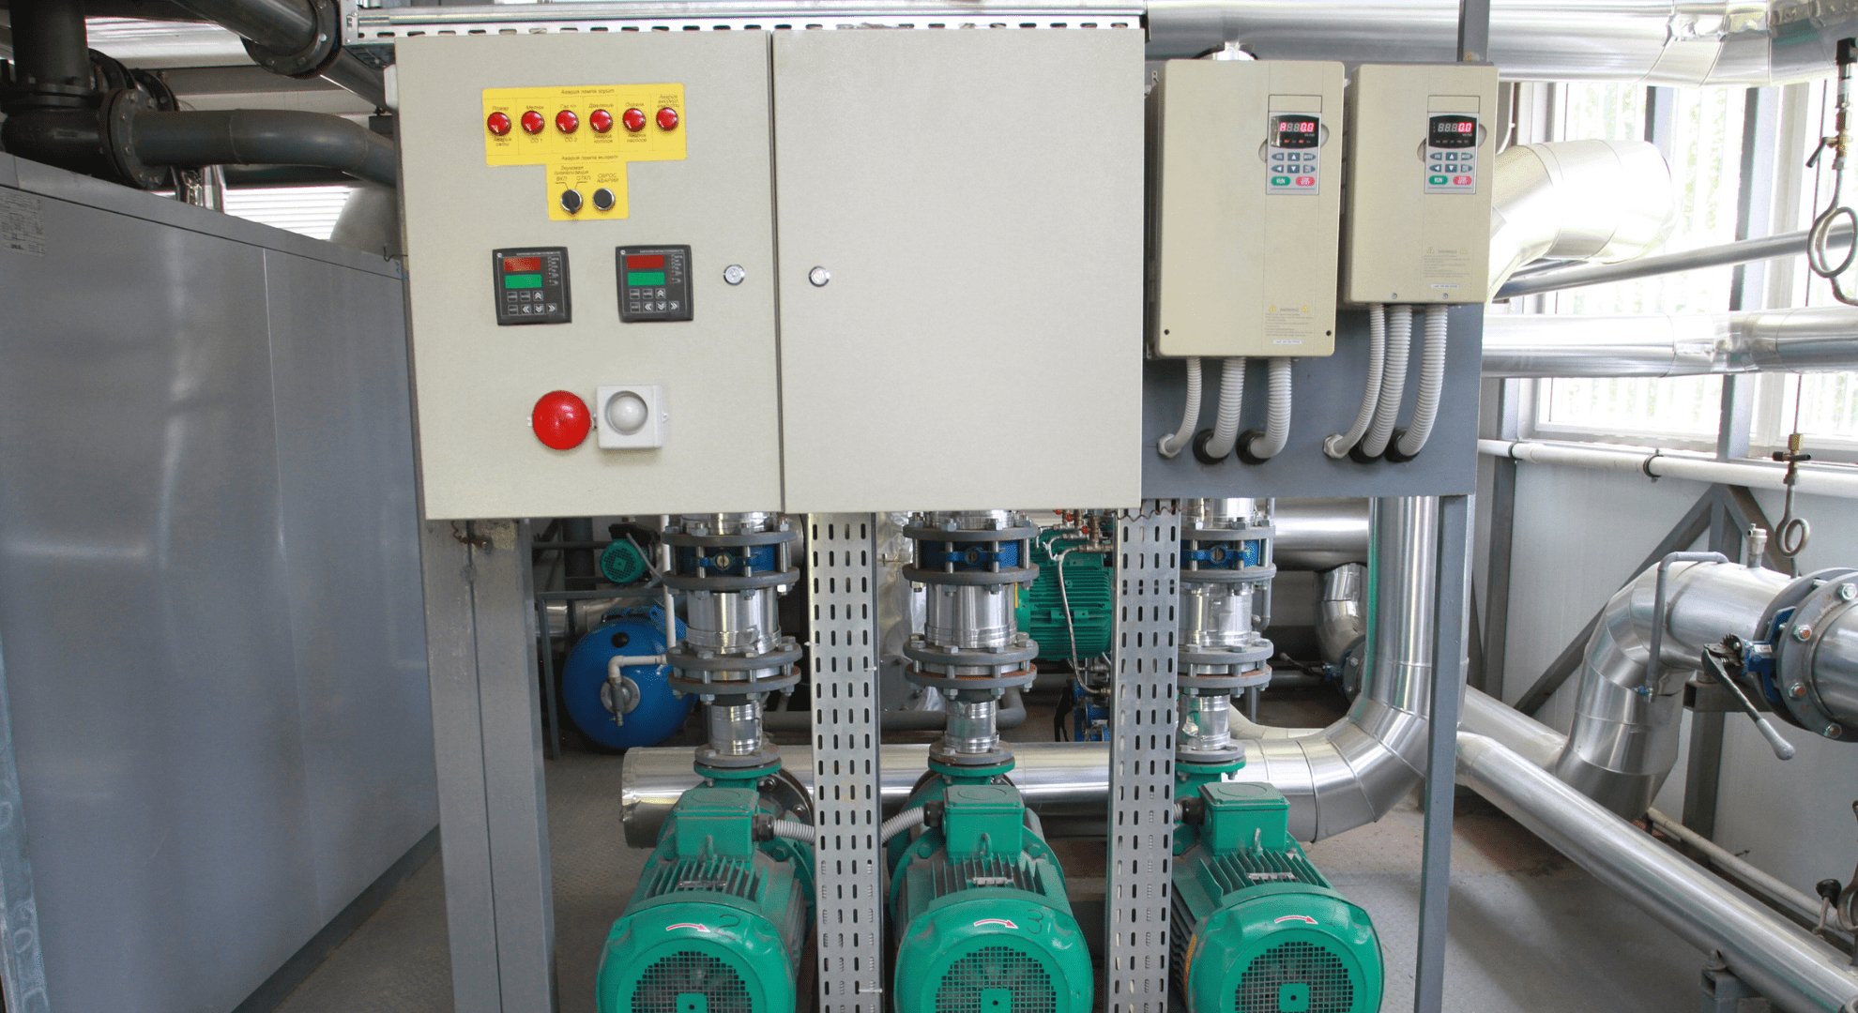
Objective of the project
Main Objective:
To design and implement a simple, reliable, efficient, cost-effective, and low-power automated water pump controller system for managing water levels in storage tanks and reservoirs.
Specific Objectives:
- Ensure low power consumption and cost efficiency for continuous operation and minimal maintenance.
- Integrate safety features to protect the pump from issues such as dry run or overflow, enhancing system reliability.
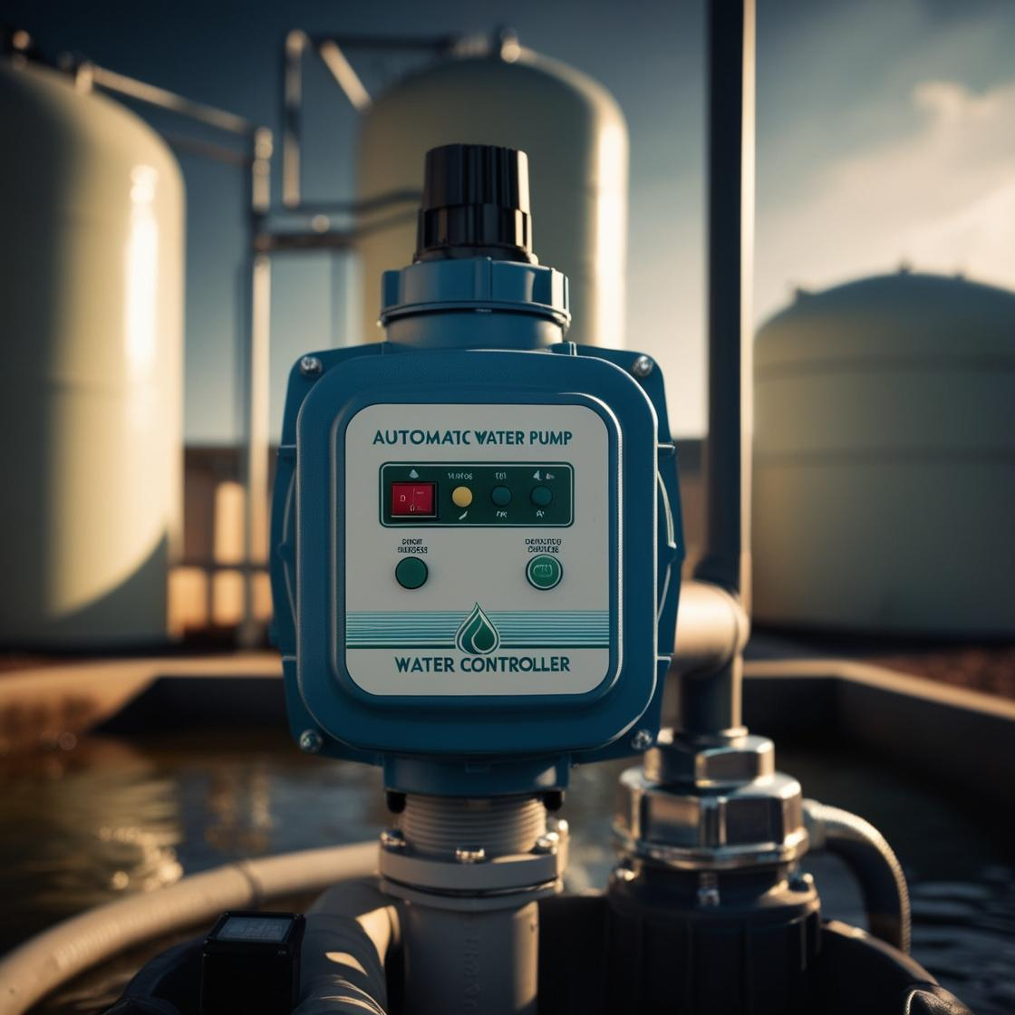
1.4 literature review:
Various methods have been developed for automated water pump control systems, employed in diverse settings to manage water levels in storage tanks and reservoirs. The optimal method depends on factors such as cost, system complexity, and ease of operation. Automatic water pump controllers can be categorized based on the sensors used and the type of control circuitry. Common sensors for water level detection include float switches, ultrasonic sensors, and conductive probes. Microcontrollers and integrated circuits (ICs), such as the 555 timer and relays, are frequently used to process signals from these sensors, enabling precise pump control and automation .
Ultrasonic sensors are often utilized in automated pump systems for water level detection by measuring the distance between the sensor and the water surface, providing real-time feedback for pump activation. However, simpler approaches like conductive probes are also popular due to their cost-effectiveness and reliability in detecting water presence at specific levels in both underground and overhead tanks

Chapter 2:System Description
This chapter provides a detailed overview of the architecture and core components of the automatic water pump controller system. Each component is explained along with its technical specifications to clarify its role and importance within the system.
2.1 System architecture and components
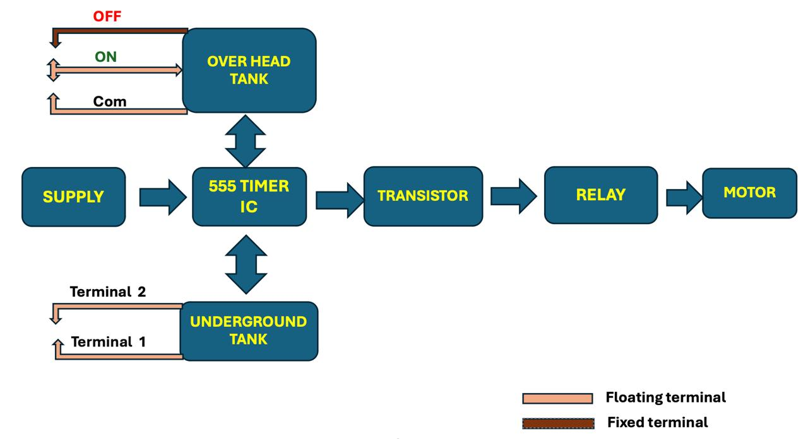

Water Level Sensing
In this segment, the water levels in both the overhead and underground tanks are monitored using conductive probes or sensors. These sensors detect the presence or absence of water at specific levels.

Signal Transmission
The information from the sensors is sent to the control unit, typically through direct electrical connections or wired circuits. This ensures real-time updates about the water level status to the central control unit.

Control Processing
The control unit, which includes a 555 Timer IC and a transistor, processes the received signals. Based on this data, it decides whether the water pump should be turned on or off, depending on the water levels in the tanks.

Activation
Finally, the processed signal triggers a relay, which then activates or deactivates the water pump

2.2 Component Required:
- 555 Timer IC
- BC547 NPN Transistor
- 1k 0.25-watt Resistors
- 22k 0.25-watt Resistors
- 180k 0.25-watt Resistor
- 1M 0.25-watt Resistors
- LED 1.5V 5-mm
- 1N4007 Diode
- 100nF (104) Capacitor
- 12V SPDT Relay (Contact Rating 30A) (
- Connectors & IC base (4 pins)

- 555 timer IC
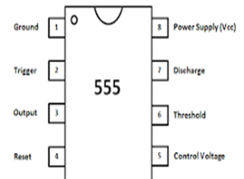

- BC547 NPN Transistor
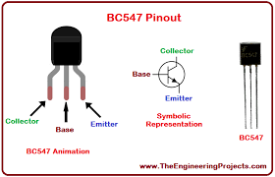

- Relay
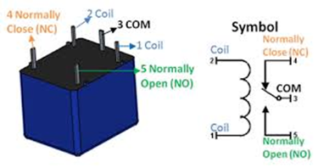

- Diode

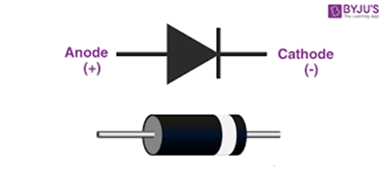
V. Resistor

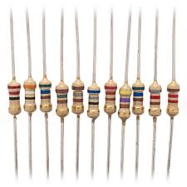
- Led
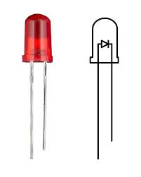
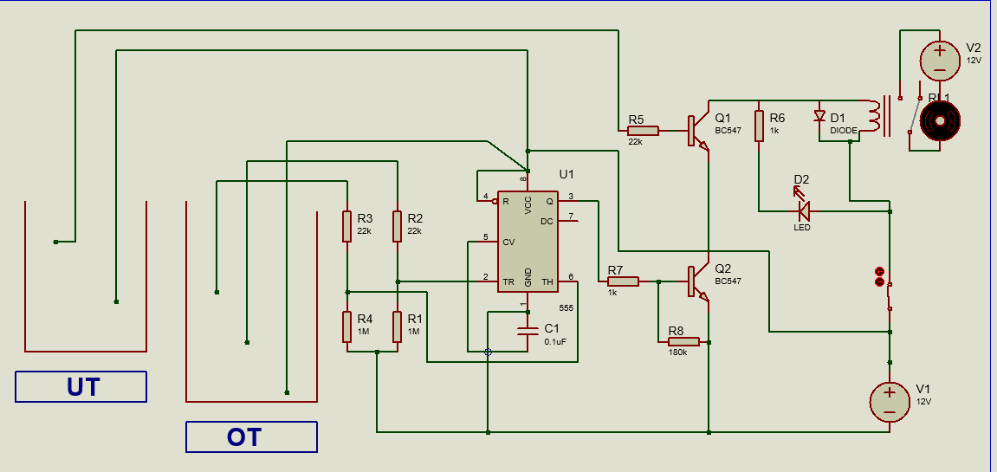
2.3 Circuit Diagram and Working Principle

1.Sensors detect water levels in the underground and overhead tanks.
2.When the overhead tank's water level drops, the sensor triggers the 555 timer.
3.The 555 timer activates a relay, which starts the water pump.
4.Water is pumped from the underground tank to the overhead tank.
5.Once the overhead tank is full, the sensor turns off the relay, stopping the pump.
6.The pump also stops if the underground tank is empty.
7.Manual override and emergency stop provide user control.

Conclusion and Recommendation for improvements

The implementation of the automatic water pump controller system successfully achieved its goal of automating the water filling process between underground and overhead tanks. By integrating sensors, a 555 Timer IC, transistors, and a relay, the system reliably manages the motor operation based on water levels. This project demonstrates an efficient and cost-effective solution for water management in households or small industries, reducing manual intervention and preventing water wastage. The successful testing phase confirmed that the design meets the operational requirements, effectively turning the pump on and off based on the specified water levels.

Future Recommendations:
- Sensor Upgrades:
Enhancing the water level detection sensors with more accurate or advanced alternatives such as ultrasonic sensors could improve system reliability, especially for larger tanks or where water quality affects sensor performance.
- Power Efficiency:
Implementing a solar-powered setup could be a sustainable upgrade, especially in areas with limited or unreliable power supply. This would ensure continuous operation while reducing electricity costs.

References

- Rao, R. K. (2016). "Embedded Systems and Robotics with Open Source Tools.
- Boylestad, R. L., & Nashelsky, L. (2017). "Electronic Devices and Circuit Theory."
- Jain, P., & Singh, S. (2020). "Smart Water Management System using IoT." International Journal of Computer Applications, 182(28), 12-16.
- Easy Electronics Projects. "Automatic Water Pump Controller Circuit Diagram

